Pre-Kharif meeting on Pulses for Dissemination of Improved technologies for major pulse crops in convergence mode for Karnataka State

An online meeting on Pre-Kharif for Dissemination of Improved technologies for major pulse crops in convergence mode for Karnataka State was conducted on 30th April 2026. It was jointly organized by ICAR-IIPR, Kanpur & IIPR- RS, Dharwad and ICAR-ATARI, Bengaluru and Karnataka State Department of Agriculture, Govt. of Karnataka. This meeting was attended by Dr. Girish Prasad Dixit, Director, ICAR-IIPR, Kanpur; Dr. Ranjay Singh, ADG (AE), ICAR, New Delhi; Dr V. Venkatasubramanian, Director, ATARI, Bengaluru; Dr Madhusudhan, Additional Director & Nodal Officer, National Pulses Mission, Karnataka State Department of Agriculture (KSDA), Govt of Karnataka; Scientists of IIPR, Kanpur, IIPR-RS, Dharwad, Scientist of ATARI, Bengaluru, Incharges and SMS of KVKs from Karnataka, Deputy Directors of Agriculture (DDA) & Joint Directors of Agriculture (JDA) and Agriculture Officers from different districts of Karnataka. Total 100 participants attended the online meeting. At outset, Dr. M H Kodandaram, Principal Scientist and State liaison officer, National Pulse Mission welcomed all the participants and briefed the purpose and importance of the meeting.

Dr. Girish Prasad Dixit, Director, ICAR-IIPR, Kanpur, in his opening remarks gave an overview of pulses production at country level and contribution of Karnataka state in national pulse production. He outlined the strategies for accelerating pulses production in the state through horizontal and vertical expansion approaches. He emphasized on the district wise cluster-based quadrant approach for increasing area and production of pulses in Karnataka. Further, he appraised that pigeonpea is an important crop of Karnataka contributing major share in the total pulse production and suggested to use recent HYV released for the state and the problem of wilt disease should be addressed in the scientific manner involving KVK and state dept. officials.

Dr. Ranjay Singh, ADG (AE), ICAR, New Delhi in his remarks appreciated the efforts of ICAR-IIPR, Kanpur in conducting Pre-Kharif meetings in association with different ATARIs, in dissemination of improved pulse varieties including production and protection technologies to KVKs and State departments. He emphasized the role of KVKs in delivering these technologies to farming community through demonstrations, CFLDs, FLDS. He suggested KVKs to include these new technologies in pulses in their annual technical program and crop plans. He further informed that now the Govt of India regularly communicating with the State Govts for successful implementation of all the schemes and programs for adoption of new technologies developed for different pulse crops. He raised the issue of wilt problem in pigeonpea in Karnataka and other pigeonpea growing areas. He suggested that KVKs should demonstrate the good agronomic practices such as growing pigeonpea on raised beds and other approaches for its control at farmer’s field. Further he appraised that recently Govt of Uttar Pradesh has decided to procure the seeds of important crops directly from CFLD/FLD clusters. Such approaches should also be worked out for the Karnataka involving State Dept Officials. He directed the IIPR and ATARI to be cautious and watchful in using only recently released pulses varieties for demonstrations under CFLD/FLDS. They should also provide advisories to KVKs and State Department in these aspects. Proper guidelines should be prepared in transfer or dissemination of technologies and resources developed by ICAR to State Govt.

Dr V. Venkatasubramanian, Director, ATARI, Bengaluru in his address acknowledged the support and efforts of ADG (AE) in monitoring of various programs at ATARI. He advised all KVKs to campaign balanced use of fertilizers and minimizing their uses in pulses crops and suggested to popularize the Integrated Nutrient management strategies. He raised the issue of climate change and its impact on pulses production in Karnataka State. He suggested that our technologies should focus on this emerging problem and develop suitable measures to mitigate the effects of climate change on pulse crops. He further appraised the issue of quality seed availability to farmers. Finaly, he requested to ADG (AE) to provide additional financial help to ATARIs and KVSs for successful implementation of new programs and campaigns in the Karnatak state.

Dr Madhusudhan, Additional Director & Nodal Officer, National Pulses Mission, Karnataka State Department of Agriculture (KSDA), Govt of Karnataka informed that the state has 34.50 L. Ha area under pulses with an output of 19.0 MT. He raised the issue of availability of recently released pulse varieties in the state. He shared that the seed requirement in Karnatak is more than 2029 q but only 1013 q seed is available. He further requested IIPR to share information on the new varieties of pigeonpea, green gram released for the Karnataka state and make necessary arrangement for their procurements. He further appraised that under National Pulse Mission the State Govt is distributing mini kits of pulses crops for demonstration in different districts of Karnataka state. He requested IIPR, Kanpur and ATARI to sensitize the state Dept officials in adoption of new technologies in pulses crops.
After the opening remarks and address of dignitaries, different presentations on various topics were made by the scientists of IIPR from Kanpur and Dharwad. Dr. B. Manu, Scientist (Plant Breeding), IIPR-RS Dharwad made a presentation on Climate Resilient pulse varieties pigeonpea, mungbean, urdbean and cowpea for Karnataka State. Dr. KK Hazara, Senior Scientist (Agronomy), ICAR-IIPR, Kanpur made a presentation on Pulses production technologies & Advisory for Karnataka. Dr. M H Kodandaram, Principal Scientist (Entomology), ICAR-IIPR-RS, Dharwad made a presentation on Emerging Insect Pests and diseases of Kharif Pulses and their management. After all the presentation by the resource persons there was interaction with the participants. Some of the key points emerged during the discussions were as follows
- All the participants requested for the information on latest pulses varieties (less than 8-year-old) recommended for the Karnataka and availability of seeds.
- KVKs requested for the bio-pesticides developed by IIPR for pest and diseases control for the demonstrations in pulse crops.
- Suitable control measures to mitigate terminal drought stress in pigeonpea for Kalburgi Dist.
- SMD resistant pigeonpea varieties and management strategies in Pigeonpea.
- Problem of Cuscuta (Dodder) weed in Pigeonpea is an emerging in some blocks of Kalburgi and need strategies for its control.
- There was demand for suitable mungbean variety other than DDGV 2 for Kharif season in Dharwad Dist.
- Necessary guidelines to be formulated in consultation with State Dept. for implementation of CFLDs in the state.
- Promotion of plant protection technologies through KVKs and availability of biocontrol inputs for pulses.
- Separate meeting for monitoring seed hubs associated with KVKs for pulses seed production.
- Organize regular meetings before each cropping seasons to sensitize the KVKs about pulses production.

After the interaction session Dr. BT Rayudu, Principal Scientist, ATARI, Bengaluru proposed vote of thanks.

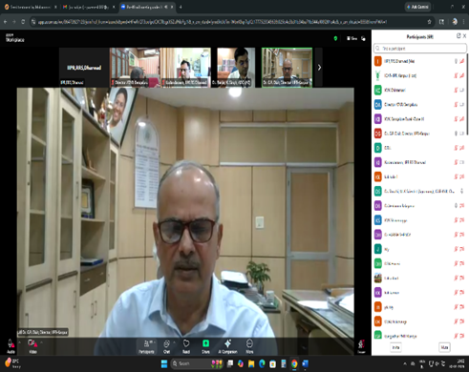 | 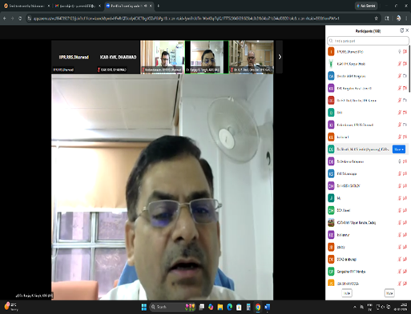
Dr. G P Dixit (Director, ICAR-IIPR, Kanpur) | Dr. Ranjay K Singh (ADG, ICAR, New Delhi)
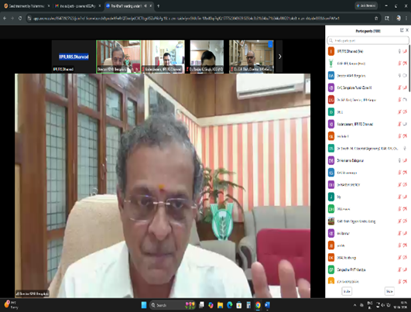 | 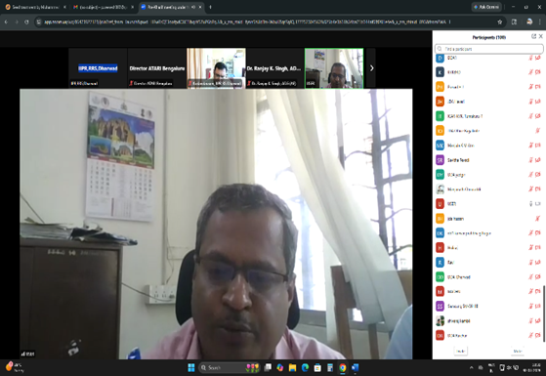
Dr. Venkatasubramanian (Director, ATARI, Bengaluru) | Dr. Madhusudhan, Additional Director &  Nodal officer, NPM, KSDA, GoK, Bengaluru
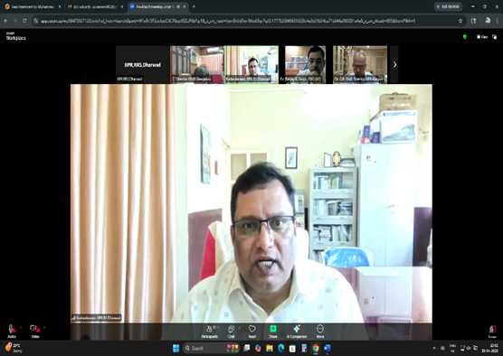 | 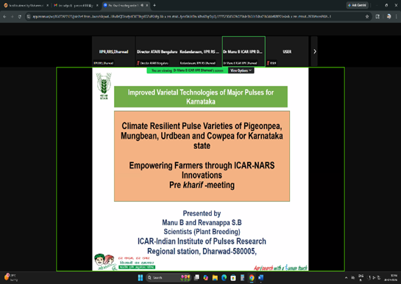
Dr. M H Kodandaram (PS & State Liasion Officer, IIPR, RRS, Dharwad) | Presentation by Dr B Manu, Scientist, IIPR, RS Dharwad

