Postharvest Technologies ICAR-IIPR, Kanpur for Institute website for inviting Expression of Interest for Technology Transfer:
S. No. | Technology(ies) | Technology Details | Technology Photographs
1. | IIPR Dal Chakki | IIPR Dal Chakki comprising of feed hopper, vertical rubber-steel disk mechanism (chakki) and cyclone separator helps in dehusking and splitting of pretreated pulse grains. From hopper grains fall on feeding auger which allows uniform feeding to the chakki. Dehusking and splitting takes place simultaneously between stationary rubber and rotating steel disks. Husk and small cotyledon particles are removed from the milled product and collected in gunny bag with help of cyclone separator. Driven by 1.5 hp single phase motor IIPR Dal Chakki and gives capacity of 75-125 kg/h for different pulses. | 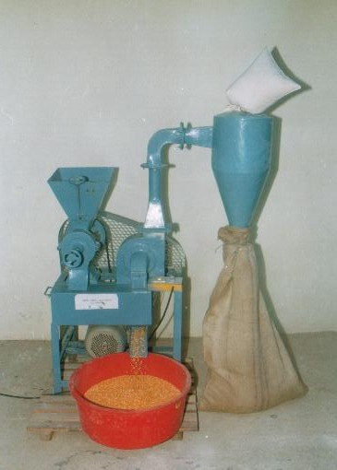
2. | Improved IIPR Mini Dal Mill | Improved model of IIPR Mini Dal Mill (Generation 4) has been developed. The mill is combination of cleaner-cum-grader, emery roller, rubber-steel disk mechanism and cyclone separator. Graded grains are passed through emery roller, for pitting or scratching prior to commonly adopted pre-treatments viz., water soaking or oil application. Conditioning for several hours followed by prolong sun drying for several days, loosens the husk. Thus, treated grains are passed through rubber-steel disk vertical chakki for dehusking and splitting. Soft dehusking minimizes the powdering loss. Emery roller helps in better dehusking of pulses. Driven by 2.0 hp single phase motor the mill gives capacity of 75-125 kg/h for different pulses. | 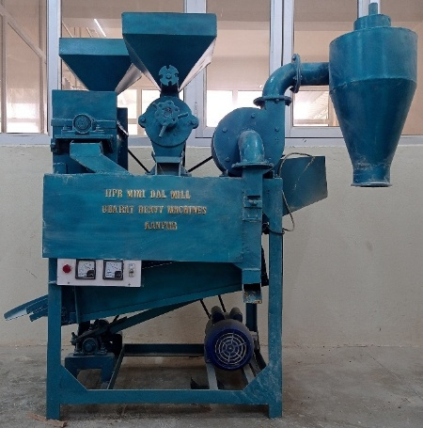
3. | IIPR Multi-purpose Grinder | Improved model of IIPR Multi-purpose Grinder has been developed with radial feed system. It is used to convert brokens obtained from milling of pulses, into grinded powder (besan). A pulse grinding unit was developed to make powder from broken cotyledons obtained from milling of pulses. Swinging beater type rotor is used to crush the till it passes through strainer provided at the outlet on lower side of the unit. This grinder was primarily developed for making ‘besan’ or ‘sattu’ from pulses, but the machine worked successfully for grinding of spices like turmeric, coriander, red chili, black pepper etc. | 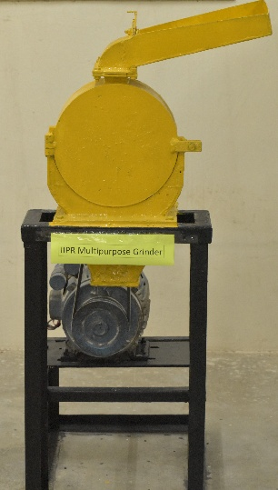
4. | IIIPR Vertical Thresher | Threshing of pulses is cumbersome process. Commercially available threshers are designed for threshing of wheat. To thresh different pulses, these threshers require adjustments in various machine parameters such as drum sieve, cylinder-concave clearance, number of pegs, peg orientation etc., which is a difficult and time consuming. Therefore, a vertical thresher was designed and developed to thresh different pulse crops without any adjustment in machine parameters. Vertical gravity feed system is adopted to thresh sun dried crop up to appropriate moisture. Chopping blades cut the sturdy straw of pulse crops. The thresher can efficiently be used for different pulses. | 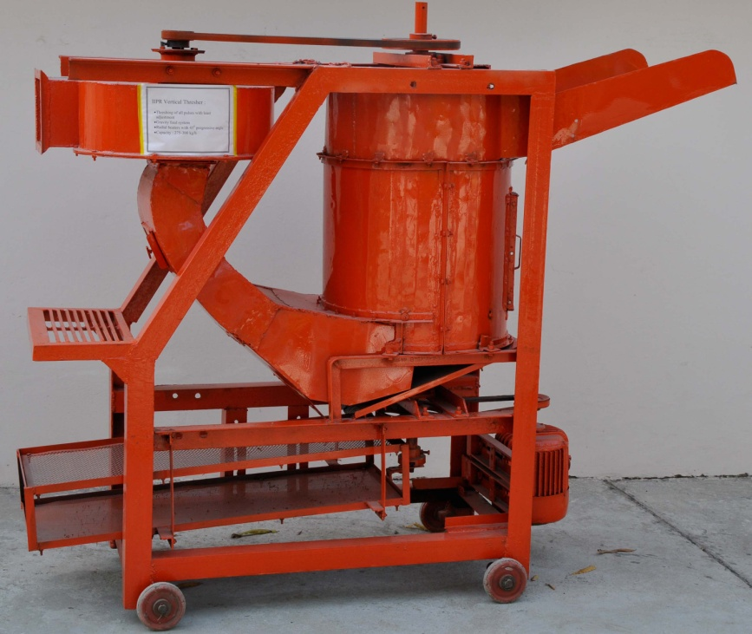
5. | IIPR Pigeonpea Stripper | Threshing of pigeonpea in commercially available threshers is difficult due to large plant size. It is difficult to feed into feeding trough and moreover, about half of the plant gets chopped and shredded in the process. Traditionally, pigeonpea plant is beaten by wooden stick or pounded over fixed surface involving drudgery. A pigeonpea stripper was designed and developed at the institute, which envisages removal of pods and leaves, with least damage to plant structure. The stripped material can be threshed in any commercially available threshers or vertical thresher developed by IIPR. | 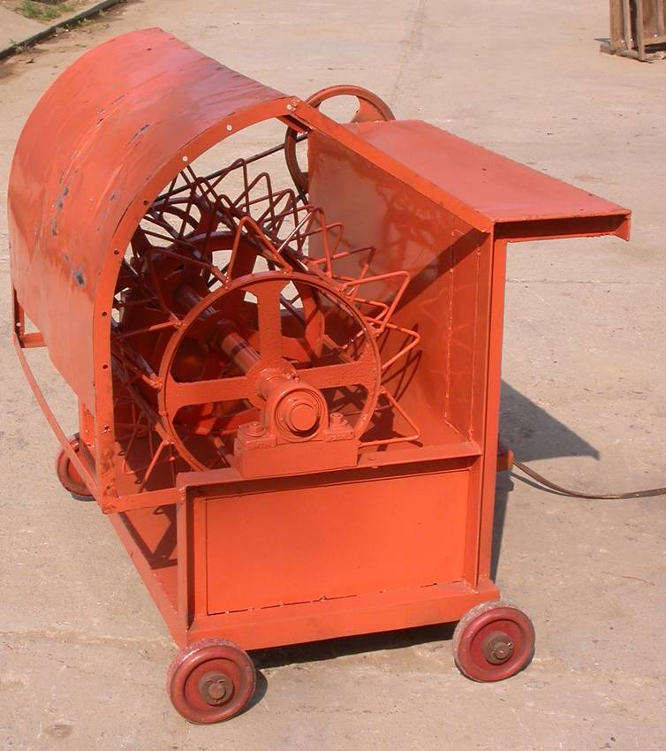
6. | IIPR Suction Winnower | For all the crops winnowing is an essential process after manual threshing. Winnowing of threshed material is an ergonomically cumbersome operation in which operator has to stand in awkward position and in front of blowing air and inhale dust laden blowing air. A winnower is developed in which operator has to fill hopper which allows free fall of material in a closed chamber in two steps. Suction blower, sucks the light impurities blow it away from operator. The unit has provision to increase or decrease blower speed using step pulley and suction by controlling air flow. | 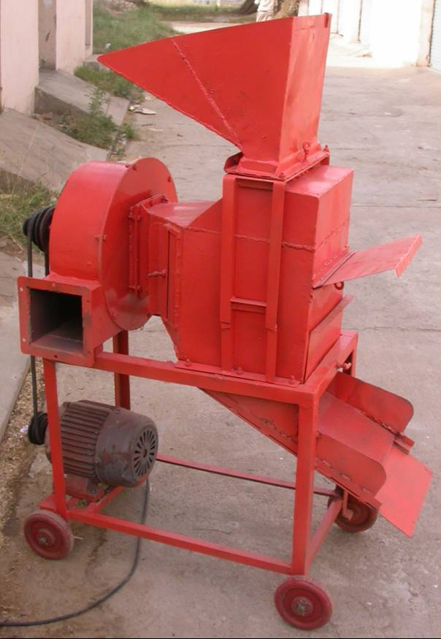
7. | IIPR Horizontal Hand Chakki | At cottage scale dal milling is performed with the help of stone chakkies. Soaking, roasting, oil applications etc. are common pretreatments adopted at domestic level. The process involves high level of drudgery and is quite cumbersome. In order to reduce drudgery, hand operated chakki, with horizontal emery disks has been designed and fabricated using bearings at central pivot and handle base. Provision for gap adjustment between the disks has also been made. Outer channel has also been provided to collect milled fractions to be delivered at single outlet. Cleaning of milled fractions is performed with the help of winnowing basket. | 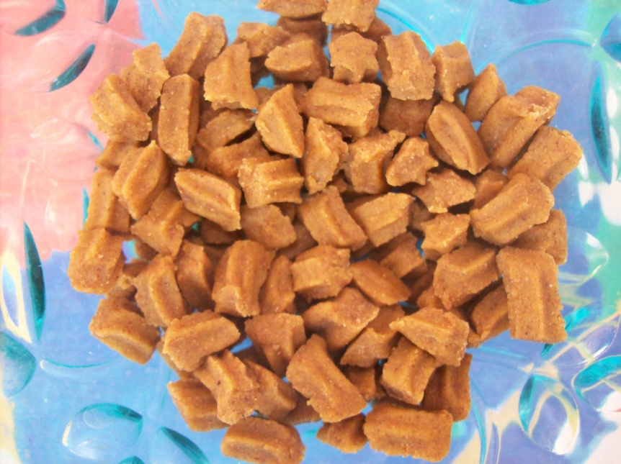  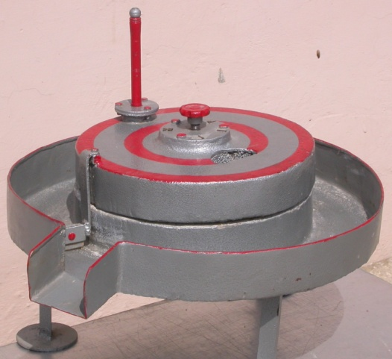
8. | IIPR Vertical Hand Chakki | A hand operated dal chakki utilizing IIPR pulse milling technology of vertical stationary rubber and rotating steel disks was designed and fabricated. This chakki has potential for adoption at domestic level in rural areas where still dal is made from stone chakkies mostly by ladies. Thoroughly pre-treated grains are fed from the hopper and gap between the disks can be adjusted according to grain size. Auger feeding mechanism helps uniform input of grains to the dehusking unit. Cleaning of milled fractions is performed with the help of winnowing basket. | 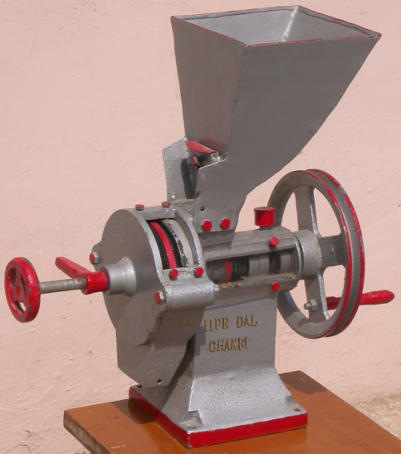
9. | Value Added Products from Pulse Milling By-products | Dal recovery in abrasive dehusking units is about 70% against the potential dal recovery of 85%. Outer layer of cotyledons which is rich in proteins gets mixed with husk due to scouring. The milling byproduct, thus, obtains is rich in proteins, fibers, phenols and antioxidants and often consumed as cattle feed. Therefore, it was envisaged to utilize the protein and fiber rich pulse milling by-product to develop high value edible products for human consumption, instead of low value cattle feed. With increasing awareness towards advantages of fiber and phenols in human diets such products can fetch better prices in the market.  The milling byproduct as such can be utilized if developing ready-to-eat or cook products in combination with other ingredients such as white flour or whole wheat flour to make biscuits. Cotyledon powder and husk components of the milling byproduct can be separated by sifting with suitable sieve size. The husk component can be used as phenol and fiber rich nutraceuticals, and the cotyledon powder can be utilized as source of pulse proteins. In the study food values of whole grain, cotyledons, byproduct and its fractions were determined, which indicates potential of utilizing the byproduct and its fractions for edible purposes.  Technologies are available individually or in bulk. | 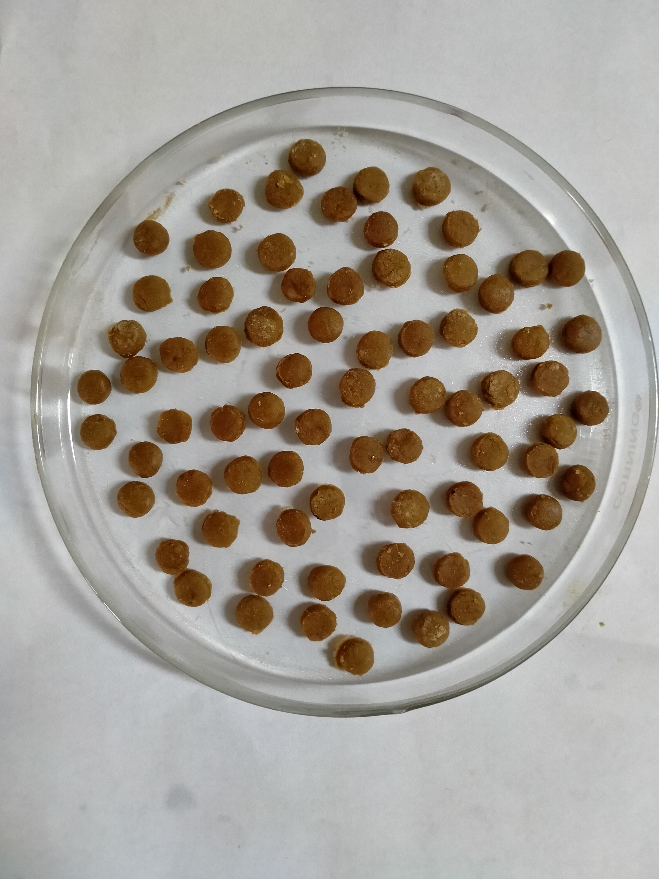  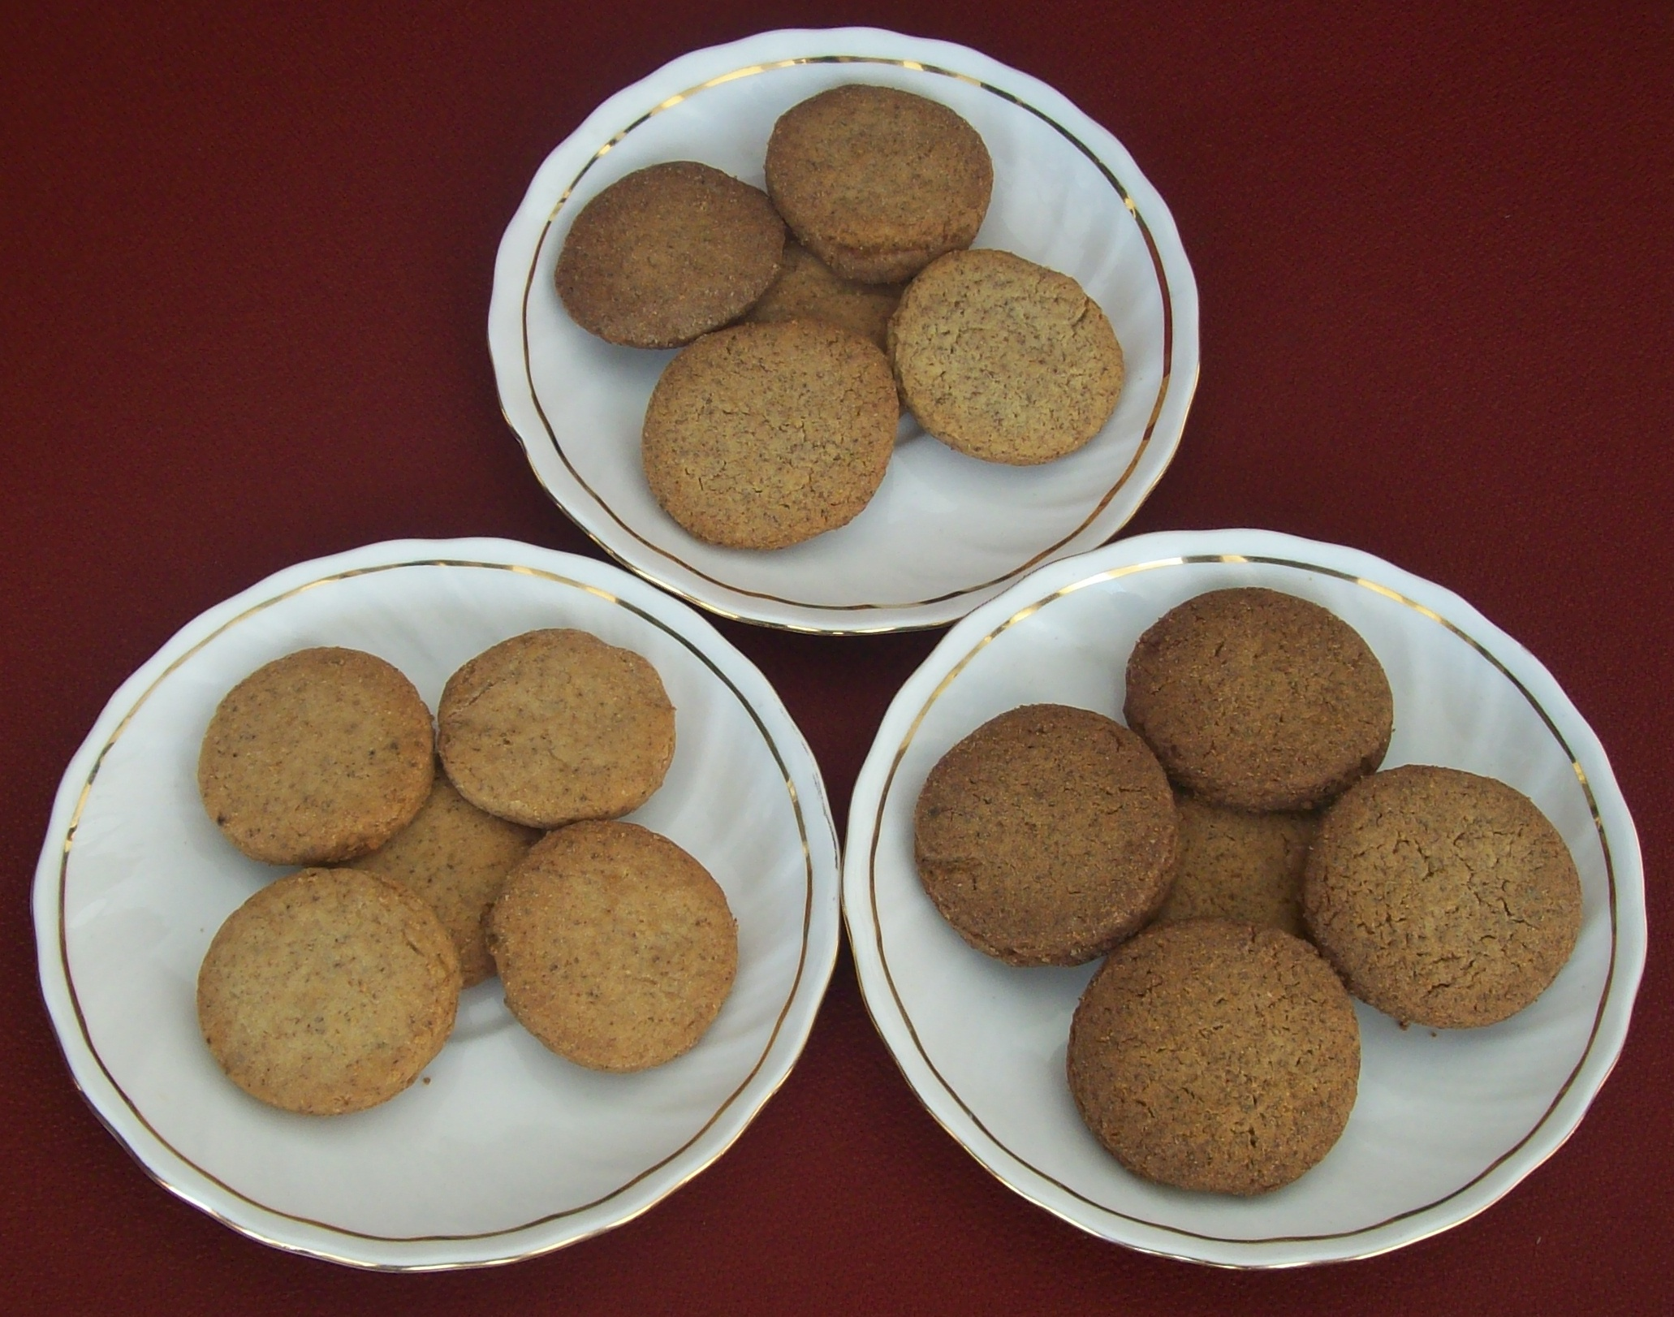  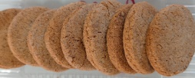  Protein Fiber Rich Biscuits  Dal Analogue  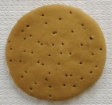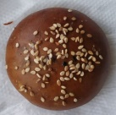  Pizza Base Bun Cakes/Muffins  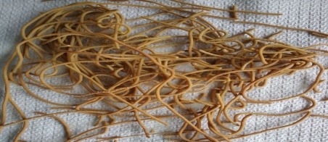  Noodles  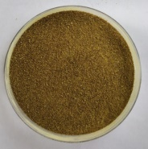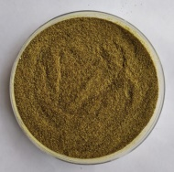  Instant Soup Instant Dal    Atta Mix Sattu  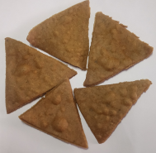  Nachos  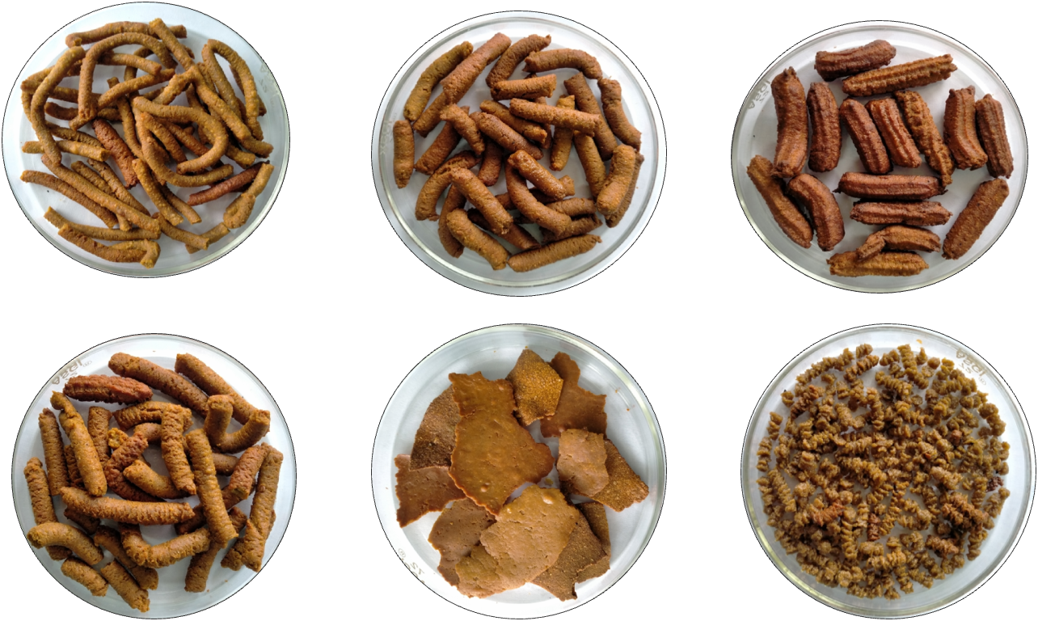  Traditional Indian Recipes

List of Postharvest Technologies and Value Added Products available at ICAR-IIPR for commercialization
1. | IIPR Dal Chakki
2. | IIPR Mini Dal Mill
3. | Pulse Threshing and Allied Machines  - IIPR Vertical Thresher  - IIPR Pigeonpea Stripper  - IIPR Suction Winnower
4. | Multipurpose grinder
5. | Hand operated vertical dal chakki
6. | Hand operated horizontal dal chakki
7. | Utilization of pulse milling byproducts for edible use – Protein & Fiber Rich Biscuits
8. | Utilization of pulse milling byproducts for edible use – Dal Analogue
9. | Utilization of pulse milling byproducts for edible use – Pizza Base
10. | Utilization of pulse milling byproducts for edible use – Bun.
11. | Utilization of pulse milling byproducts for edible use – Cakes and Muffins
12. | Utilization of pulse milling byproducts for edible use – Noodles
13. | Utilization of pulse milling byproducts for edible use – Instant Pulse Soup
14. | Utilization of pulse milling byproducts for edible use – Instant Dal
15. | Utilization of pulse milling byproducts for edible use – Flour (Atta) Mix
16. | Utilization of pulse milling byproducts for edible use – Sattu
17. | Utilization of pulse milling byproducts for edible use – Nachos
18. | Protocols for milling of pulses in IIPR Mini Dal Mill

