FPO connect 2.0 organized by Pulses Innovation Hub, Agri-Business Incubation Centre, ICAR-IIPR, Kanpur
Pulses Innovation Hub, Agri Business Incubation Centre (ABIC) of ICAR-IIPR, Kanpur, successfully organized FPO Connect 2.0 on 29th September 2025. A total of 27 FPO representatives from different states (UP, MP and Bihar) participated in this program with keen interest in adopting pulse-based technologies and building sustainable business models.
The program was inaugurated by Dr. G. P. Dixit, Director, ICAR-IIPR, Kanpur, who emphasized the importance of empowering FPOs through improved technologies, enhanced market linkages, and innovation-driven business strategies in the pulses sector.
The technical sessions included insightful lectures by eminent experts, Dr. R. K. Mishra (PI, ABIC), Dr. P. K. Katiyar, Dr. Prasoon Verma, Dr. Yogesh Kumar, Dr. M. Senthil Kumar, and Dr. Manmohan Deo covering various aspects of technology adoption, seed systems, value addition, and entrepreneurship in pulses.
Interactive sessions provided participants an opportunity to engage directly with scientists and incubation experts, encouraging discussions on business prospects in pulses processing, branding, and marketing. The participants appreciated the platform for its practical insights, networking opportunities, and exposure to innovative agribusiness solutions designed for FPO-led ventures.
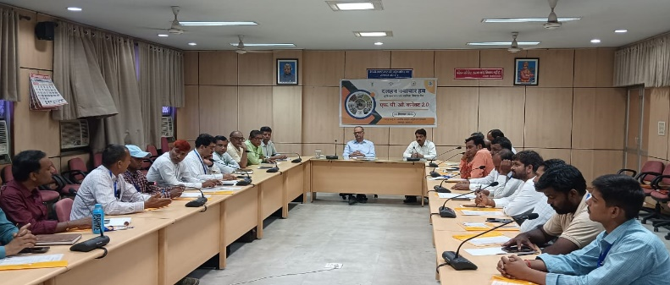
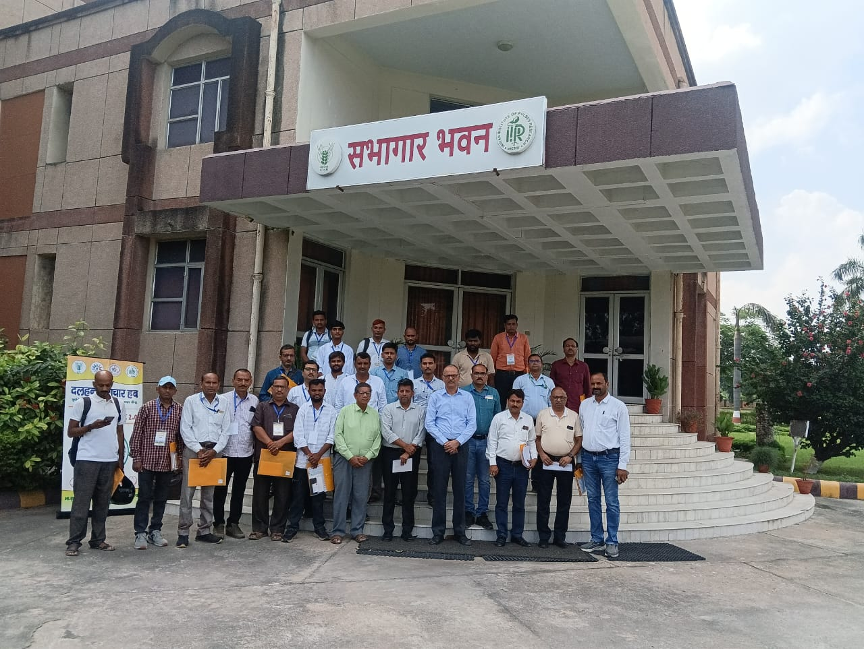
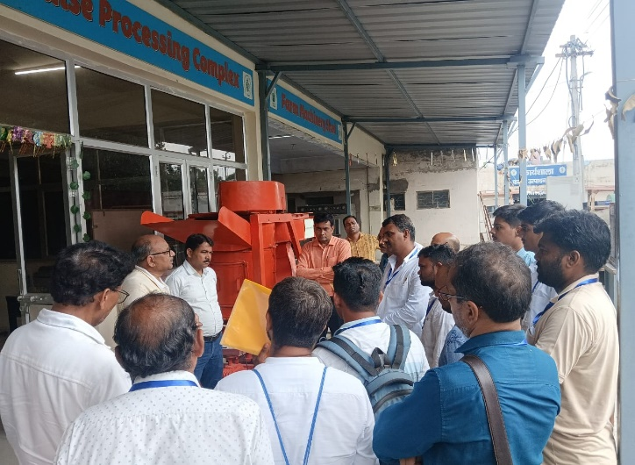
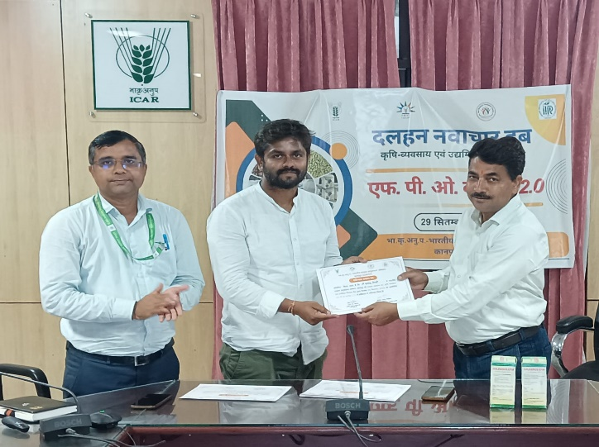
On the concluding session, Dr. Mishra (PI, ABIC) and Dr. Manmohan Deo (Mentor, ABIC), distributed certificates of participation to the FPO representatives.

