The 20th Parthenium Awareness Week (16-22nd August 2025) organized at ICAR-IIPR, Kanpur and its regional station
The 20th Parthenium Awareness Week (16-22nd August 2025) was organized at ICAR-IIPR, Kanpur and its regional station, Dharwad during August 21-22, 2025. The programmes was organized under the supervision and guidance of Dr. G.P. Dixit (Director, ICAR-IIPR, Kanpur). On this occasion, Dr. Narendra Kumar, Head (Division of Crop Production) and Dr. S.L. Patil, PS and Officer-in-Charge, ICAR-IIPR-RRS, Dharwad stressed upon the importance of eradicating the Parthenium hysterophorus from our sorrounding research farm, villages, and in the city areas. They elaborated the different meance caused by the Parthenuim weed to the environment, agriculture, biodiversity, and human health. Further awareness was created on managing the Parthenium by agronomic, chemical, and biological methods. It was mentioned that with effort over the years, the campuses have become almost partheunium free. Scientific, technical and contractual staffs of Division of Crop Production, and Incharges of Farms, and Farm Manager of ICAR-IIPR, Kanpur and ICAR-IIPR-RRS, Dharwad were present on the ocassion and uprooted the Parthenium weed in the experimental fields/farms. The programme was aimed to raise awareness regarding the negative impact of Parthenium and mobilize collective action towards its control and eradication. The prgramme was co-ordinated by Dr. C.P. Nath, Senior Scientist (Agronomy).

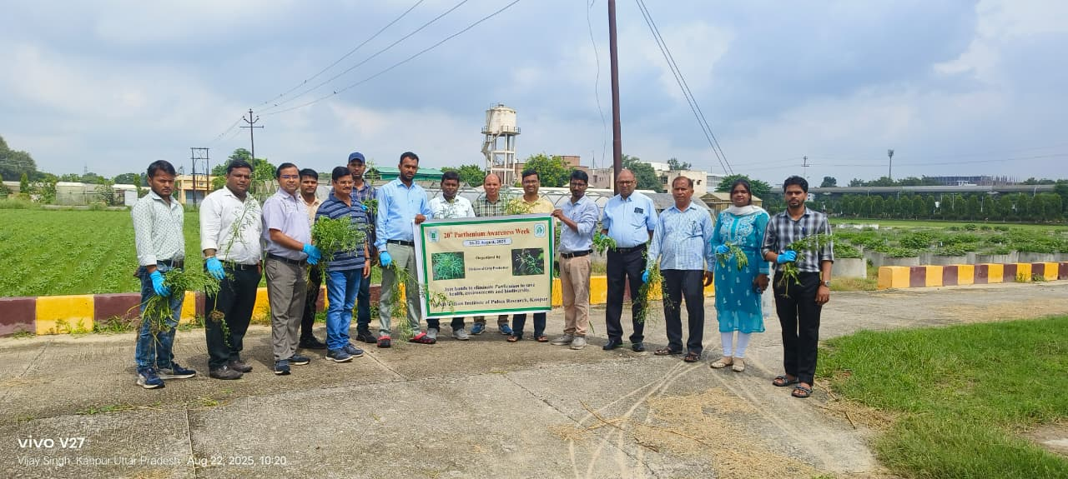 | 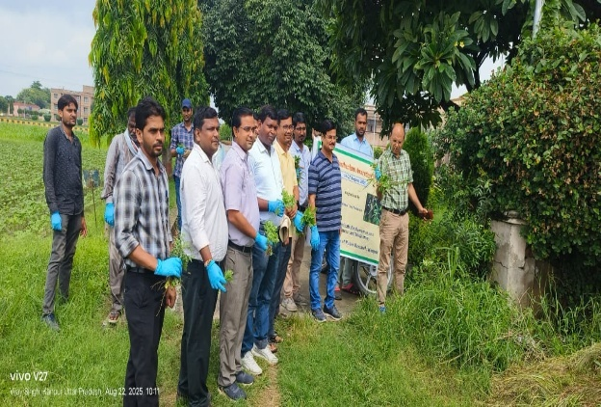
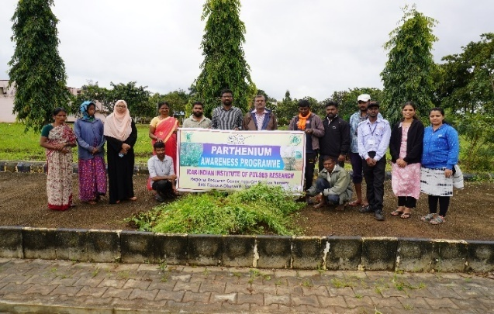 | 