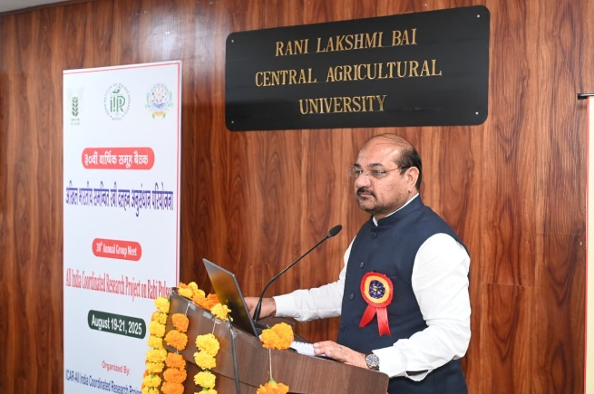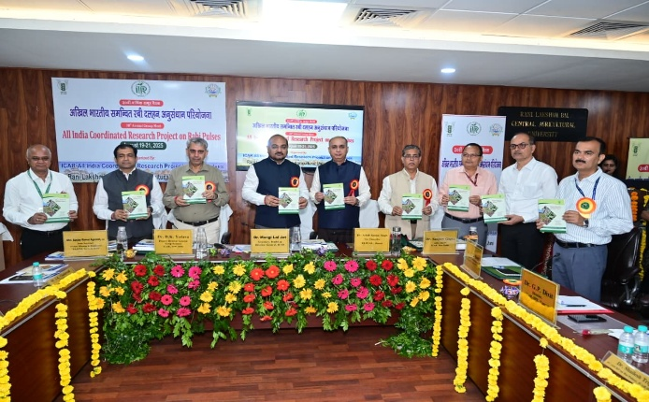

Secretary DARE and Director General, ICAR, New Delhi, Dr. M.L. Jat, chaired the inaugural session of the Annual Group Meet of All India Coordinated Research Project (AICRP) on Rabi Pulses and a brainstorming session on ”Roadmap for attaining self-sufficiency in pulses production” held at RLBCAU, Jhansi on 19th August 2025. The group meet was attended by more than 175 scientists from different organizations, i.e., State Agriculture Universities, BARC, ICRISAT, ICARDA, and ICAR institutes. Dr. Jat addressed the august gathering and emphasized to prepare an implementable action plan to achieve self-sufficiency in pulses. In the context of pulses, he mentioned about 3P approach for growing pulses, People, Planet, and Profit. He mentioned that pulses are important for both people as well as the planet, but at the same time for increasing pulses production the scientists should put in efforts to make pulses cultivation profitable for farmers. He also emphasized that our research and development programme must be aligned with the local socio-economic system. He suggested that scientists should focus on designing high-yielding cultivars suitable for surface seeding, relay cropping, stress-prone areas, and high/low input areas. The Deputy Director General (Crop sciences), ICAR, Dr D K Yadava, said that scientists should make efforts to develop production and protection technologies to minimize crop loss due to weeds, disease, and insect pests. He said dedicated efforts should be made to mechanize pulse cultivation from planting to harvesting.